**State of Illinois**

**Jim Underwood, Executive Director**

**JB PRITZKER, Governor**

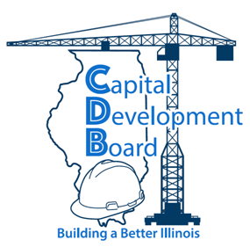

**NOTICE OF**

**CHANGE OF TIME**

**CAPITAL DEVELOPMENT BOARD**

**OCTOBER 20, 2020 MEETING**

The Capital Development Board of the State of Illinois hereby gives notice of a change in the time for a Meeting scheduled for October 20, 2020 for the Capital Development Board that was originally scheduled for 11:00 a.m. The meeting time has been changed to **1:00 p.m.**

If you have any questions or concerns, please contact:

Sally -Finney at [sally.finney@illinois.gov](mailto:sally.finney@illinois.gov) / (217) 782-8726

or

Heather Bova at [heather.bova@illinois.gov](mailto:heather.bova@illinois.gov) /(217) 782-0700.

**Board Members**

Eileen Rhodes

***Chair***

Glyn M. Ramage

Pam McDonough

Martesha Brown

David Arenas

Beverly Potts

**Wm. G. Stratton Building**

401 South Spring Street

Third Floor

Springfield, Illinois

62706-4050

**James R. Thompson Center**

100 West Randolph Street

Suite 14-600

Chicago, Illinois

60601-3283

**Dunn-Richmond Economic**

**Development Center**

1740 Innovation Drive

Suite 258

Carbondale, Illinois

62903-6102

**IDOT District 3 Headquarters**

700 East Norris Drive

Second Floor

Ottawa, Illinois

61350-0697

**East St. Louis**

**Community College Center**

601 James R. Thompson Blvd.

Building B., Suite 2079

E. St. Louis, Illinois

62201-1129

217.782.2864

217.524.0565 FAX

217.524.4449 TDD

*www.illinois.gov/cdb*