Record Drawing Certification Form

RECORD DRAWING CERTIFICATION FORM

CDB Project No.:

Project Phase:

Building Number:

Project Description:

Using Agency:

Project Location:
This date, 20 Firm: ___________________________________________________
Firm Registration Number: ___________________________________________________
the project Architect/Engineer, submits herewith record construction drawings of the above project in electronic format as listed below:

This certification shall constitute the Architect’s and/or Engineer’s original signature(s) on the record drawings in accordance with Illinois law. All parties signing the original drawings must sign and seal this form. Attach additional pages, if necessary.

Seal PRINTED NAME: _________________________

SIGNED:
AUTHORIZED SIGNATURE

Seal PRINTED NAME: _________________________

SIGNED:
AUTHORIZED SIGNATURE

Policy for Bid Set & Record Drawing Electronic Submittals
Revised June 2017

In an effort to improve efficiency and more easily share information, the Capital Development Board began requiring copies of bid documents in an electronic format, as of July 1, 2001.
Specifically, CDB requires at bid:
- One, 100% complete, set of “Issued for Bid” drawings on CD(AutoCAD format)
- One set of drawings in a single PDF file on CD
- One PDF-formatted copy of the Project Manual cover-to-cover, including all addenda, on compact disk

At project close-out:
- One, 100% complete, set of “Project Record” drawings on CD(AutoCAD format)
- One set of drawings in a single PDF file on CD
- One PDF-formatted copy of the Project Manual cover-to-cover, including all addenda, on CD
- Printed record drawings may be required (as defined below)

These requirements apply to all contracts executed since April 2000:

- Only the “Issued for Bid” drawings will be allowed on the “Issued for Bid” drawings CD. Only the “Project Record” drawings will be allowed on the “Project Record” drawings CD.

- Use “pack-n-go” or “eTransmit” utility to organize files in the root directory of the CD.

- If you are using the CAD product MicroStation or any other CAD program, then you must convert the software support files and drawings to AutoCAD format. Please ensure that all project drawings and support files convert fully and are 100% complete and organized in the CD Root Directory as described below.

- CD file structure: Drawing files must be listed before the support files and must appear in the same order as the drawing index. All support files must appear after the drawing files. Support file order may be random. Be sure to include all necessary support files such as Xref, fonts, and image files. Do not put files in folders. All files must be in the root directory.

- Drawing files may be renamed to ensure that they appear in the correct order. This can be done by adding numerical prefixes to the drawing names and adding the discipline with a number, as shown below. PLEASE NOTE: DO NOT BEGIN A FILE NAME WITH AN UNDERSCORE.

File naming examples: A/E’s drawing name Rename to
“G-1.dwg" 001_G1-0.dwg
“C-1.dwg 002_C1-0.dwg
“A-1.dwg” 003_A1-0.dwg

- CAD Viewer: We strongly recommend you utilize a viewer to preview drawings prior to submittal to ensure view ability.

- Electronic seals (with expiration date) are required on all of the drawings on the “Issued for Bid” drawings CD and the “Project Record” drawings CD. Additionally, the “Date Signed” and ”Signature” is required with the Seal on the Project Manual cover. PLEASE NOTE: DO NOT INCLUDE ELECTRONIC SIGNATURES ON DRAWINGS. The Record Drawing Certification Form with the respective Architect’s and/or Engineer’s seal and original signature is required to accompany the Record Drawings CD. A copy of the Record Drawing Certification Form is located on the previous page. Any printed bid or record documents will continue to require the seal and signature of the respective licensed Architect and/or Engineer.

- Printed final record drawings will remain a requirement for our using agencies only if contracted. CDB will not require printed final record drawings for its own use unless otherwise directed by the project manager.

- Send CDs, and Signature Page if applicable, to your CDB Project Manager for distribution within CDB.

- Please see attached checklist. CDB has provided this checklist to assist you in making sure you have prepared your Bid set and Final Record document submittals correctly.

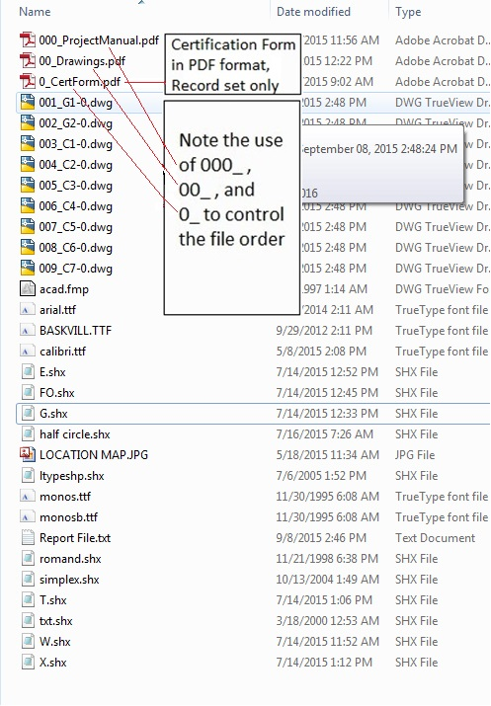
Sample Drawing Submission Rejection Notification
___________________________________________________________________________________________________________
CDB Project Number: |  | Project Manager:
Project Description: |  | Bldg. Inventory #:
Architect/Engineer: |  | Phone Number:
Contact Person: |  | Contact Email:

This submittal is for: Bid Documents Record Documents
1. Disc must be labeled with CDB Project Name, Project Number, Project phase and CDB Bldg. Inv. No. (Bid &Record Drawings)
2. All files must be on one disc – DWG Files, PDF Versions of the Drawings, Project Manual, Cert Form and all support files.
3. All files must appear in root directory, in the correct order. Ex: 000_ProjectManual.pdf, 00_Drawings.pdf, 0_CertForm.pdf. No folders. Should not Include, eTransmit .txt files. If included, they must appear below the AutoCAD drawings in the CD’s listing.
4. Must have one complete PDF file of the Project Manual, cover-to-cover, including any/all addenda (Bid only, Sec 00 91 00).
5. Must have one complete PDF file containing all drawings, in drawing index order, in addition to the AutoCAD drawing files.
6. Disc must include electronic drawings and must be in AutoCAD’s DWG format.
7. Documents must be properly named or numbered per Design Construction Manual (Article 9). Ex: 001_G1-0, 002_E1-0, 003_F1…
8. Correct CDB Project Number must appear on each drawing and the cover of the Project Manual.
9. CDB Building Inventory Number(s) for each building affected by the project must appear on the first sheet of the drawings and the cover of the Project Manual.
10. Each appropriate design professional must seal/sign/date the Project Manual cover and seal each sheet of the drawings.
11. Missing License Expiration date on Project Manual and/or Drawings.
12. Missing, illegible, or irreproducible electronic A/E seals.
13. Dates of addenda and other changes have been properly recorded in the Project Manual.
14. ALL required support files (Xrefs, Image files, Fonts, etc.) must be in the root directory on the disc. You may use “eTransmit” to extract all of the files from folders and place in the root directory. Recommended: Use free Version of DWG TrueView from AutoDesk on a machine that does not have AutoCAD installed. Open Drawing and press “F2”.
15. Document Date (Bid Date) must be the same on each drawing (Right Hand Side) and match the Project Manual Document Date.
16. Missing Date Signed on Project Manual and/or Drawings (right side of the Title Block).
17. Drawing list must be updated to include addenda (for Bid) and new and/or revised sheets (e.g. change orders for Rec. dwgs).
18. The following note must appear on all drawing sheets: ”NOTE: CONTRACTOR SHALL VERIFY ALL DIMENSIONS AND CONDITIONS AT JOB SITE AND BE FULLY RESPONSIBLE FOR SAME” (preferably on the lower left on top of the title block).
19. Disclaimers, Copyrights, and conditional statements are not allowed.
20. The words “Record Drawings” and the same Record Drawing date must appear in the Revisions section, on each drawing.
21. Must have PDF Record Drawing Cert form (0_CertForm.pdf) on disc- signed/sealed by EACH DISCIPLINE which signed/sealed the original bid docs. The Cert Form included with Record Drawings only.
22. Please review the A/E Electronic Submittal Form and Checklist from our Architect/Engineer services section on our website.

Comments:__________________________________________________________________________________ _____
- Comments Here.

http://www.illinois.gov/cdb. Revised: 07/2017

Space for A/E Comments
Item | Comment

Space for CDB Comments Only
Submittal is Approved |  | Submittal is Rejected
Item | Comment

General Information

- The “document date” is an arbitrary date set by the A/E and is the date indicated in the title block of each drawing and on the cover of the project manual. It is the date the project hit the streets, or documents ready for bidding date. Once established, it cannot change.

- If the professional who originally sealed the documents is no longer with the firm, the original seal shall be left in place on all sheets and a seal from one of the firm’s principals shall be added to the cover sheet only, with a statement of explanation similar to the following:

(Name of professional who left the firm), licensed architect/professional engineer/other professional, who as the designer of record originally signed and sealed these documents is no longer employed by (name of firm), and I (Principal in the firm), a principal of (name of firm), am authorizing (name of Professional) currently employed by (the firm) to seal the Record Drawings in his/her stead.

- The documents in the Bid submittal should be exact duplicates of what was issued for bid, even if mistakes are present.

- The Bid documents should include all documents originally issued and complete addenda including attachments.

- Substituted fonts are a common reason for rejection of submittals. This can easily be checked by loading each drawing in AutoCAD and pressing the “F2” key to see if any fonts were substituted.

