RECORD DRAWING CERTIFICATION FORM

CDB Project No.:

Project Phase:

Building Number:

Project Description:

Using Agency:

Project Location:
This date, 20 Firm: ___________________________________________________
Firm Registration Number: ___________________________________________________
The project Architect/Engineer, submits herewith record construction drawings of the above project in electronic format as listed below:

This certification shall constitute the Architect’s and/or Engineer’s original signature(s) on the record drawings in accordance with Illinois law. All parties signing the original drawings must sign and seal this form. Attach additional pages, if necessary.

Seal PRINTED NAME: _________________________

SIGNED:
AUTHORIZED SIGNATURE

Seal PRINTED NAME: _________________________

SIGNED:
AUTHORIZED SIGNATURE

Policy for Bid Set & Record Drawing Electronic Submittals
Revised July 2020

All bid set and record drawing submittals should be sent to the Capital Development Board Project Manager via an electronic file transfer site. The State of Illinois site can be used, https://filet.illinois.gov/

CDB requires at bid:
- One, 100% complete, set of “Issued for Bid” drawings in AutoCAD format
- One set of drawings in a single PDF file
- One PDF-formatted copy of the Project Manual cover-to-cover, including all addenda

At project close-out:
- One, 100% complete, set of “Project Record” drawings in AutoCAD format
- One set of drawings in a single PDF file
- One PDF-formatted copy of the Project Manual cover-to-cover, including all addenda
- One PDF copy of the Record Drawing Certification Form
- Printed record drawings may be required (as defined below)

The following requirements apply to all contracts:

- “Issued for Bid” drawings and “Project Record” drawings should be submitted separately.

- Use “eTransmit” utility to organize files in the root directory.

- If you are using any other CAD program, then you must convert the software support files and drawings to AutoCAD format. Please ensure that all project drawings and support files convert fully and are 100% complete and organized in the Root Directory as described below.

- The file structure: Drawing files must be listed before the support files and must appear in the same order as the drawing index. Support file order may be random. Be sure to include all necessary support files such as Xref, fonts, and image files. Do not put files in folders. All files must be in the root directory.

- Drawing files may be renamed to ensure that they appear in the correct order. This can be done by adding numerical prefixes to the drawing names and adding the discipline with a number, as shown below. PLEASE NOTE: DO NOT BEGIN A FILE NAME WITH AN UNDERSCORE.

File naming examples: A/E’s drawing name Rename to
“G-1.dwg" 001_G1-0.dwg
“C-1.dwg 002_C1-0.dwg
“A-1.dwg” 003_A1-0.dwg

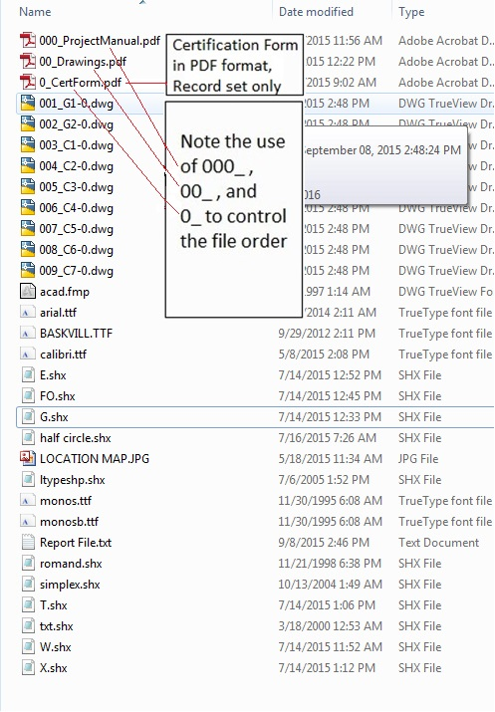

- CAD Viewer: We strongly recommend you utilize a viewer to preview drawings prior to submittal to ensure view ability. Substituted fonts are a common reason for rejection of submittals. This can easily be checked by loading each drawing in AutoCAD and pressing the “F2” key to see if any fonts were substituted.

- Electronic seals (with expiration date) are required on all of the drawings on the “Issued for Bid” drawings and the “Project Record” drawings. Additionally, the “Date Signed” and” Signature” is required with the Seal on the Project Manual cover. PLEASE NOTE: DO NOT INCLUDE ELECTRONIC SIGNATURES ON DRAWINGS. The Record Drawing Certification Form with the respective Architect’s and/or Engineer’s seal and original signature is required to accompany the Record Drawings. A copy of the Record Drawing Certification Form is located on the previous page. Any printed bid or record documents will continue to require the seal and signature of the respective licensed Architect and/or Engineer.

- Printed final record drawings will remain a requirement for our using agencies only if contracted. CDB will not require printed final record drawings for its own use unless otherwise directed by the project manager.

- The “document date” is the “Issued for Bid” date set by the A/E and is the date indicated in the title block (on the right) of each drawing and on the cover of the project manual. Once established, it cannot change.

- The documents in the Bid document submittal should include all documents originally issued and complete addenda including attachments. The documents should be exact duplicates of what was issued for bid, even if mistakes are present.

- If the professional who originally sealed the documents is no longer with the firm, the original seal shall be left in place on all sheets and a seal from one of the firm’s principals shall be added to the cover sheet only, with a statement of explanation similar to the following:

(Name of professional who left the firm), licensed architect/professional engineer/other professional, who as the designer of record originally signed and sealed these documents is no longer employed by (name of firm), and I (Principal in the firm), a principal of (name of firm), am authorizing (name of Professional) currently employed by (the firm) to seal the Record Drawings in his/her stead.

- Please see attached checklist. CDB has provided this checklist to assist you in making sure you have prepared your Bid set and Final Record document submittals correctly.

Sample Drawing Submission Rejection Notification
CDB Project Number: |  | Project Manager:
Project Description: |  | Bldg. Inventory #:
Architect/Engineer: |  | Phone Number:
Contact Person: |  | Contact Email:
___________________________________________________________________________________________________________

This submittal is for: Bid Documents Record Documents
1. For electronic submissions include in message or in subject line CDB Project Name, Project Number, Project phase, sender contact information and name of CDB Project Manager. (Bid &Record Drawings)
2. All documents should be submitted in a single electronic transmission and should include – DWG Files, PDF Versions of the Drawings, Project Manual, Cert Form and all support files.
3. All files must appear in root directory, in the correct order. Ex: 000_ProjectManual.pdf, 00_Drawings.pdf, 0_CertForm.pdf. Do not use separate folders. All other support files must appear below the AutoCAD drawings in the root directory.
4. Must have one complete PDF file of the Project Manual, include any/all addenda in Sec 00 91 00 of Table of Contents.
5. Must have one complete PDF file containing all drawings, in drawing index order.
6. Must include drawings and must be in AutoCAD. All required support files such as fonts, reference files, images, overlays, etc. shall be uploaded with the drawing files and must be in the root directory.
7. Documents must be properly named or numbered per Design Construction Manual (Article 9). Ex: 001_G1-0, 002_E1-0, 003_F1…
8. Correct CDB Project Number must appear on each drawing and the cover of the Project Manual.
9. CDB Building Inventory Number(s) for each building affected by the project must appear on the first sheet of the drawings and the cover of the Project Manual.
10. Each appropriate design professional must seal/sign/date the Project Manual cover and seal each sheet of the drawings including the license expiration date. Seals must be legible and reproducible.
11. Document Date must be the same on each drawing (Right Hand Side) and match the Project Manual Document Date.
12. The following note must appear on all drawing sheets: ”NOTE: CONTRACTOR SHALL VERIFY ALL DIMENSIONS AND CONDITIONS AT JOB SITE AND BE FULLY RESPONSIBLE FOR SAME” (preferably on the lower left on top of the title block).
13. Disclaimers, Copyrights, and conditional statements are not allowed.
14. The words “Record Drawings” should be labeled on contract documents with a Record Drawing date located in the Revisions section of the title block on all drawing sheets (Article 22.2 DCM Supplement).
15. Must submit PDF Record Drawing Cert form for each discipline which signed/sealed the original bid docs. The Cert Form is included with Record Drawings only.
16. Please review the A/E Electronic Submittal Form and Checklist from our Architect/Engineer services section on our website.

Comments:__________________________________________________________________________________ _____
- Comments Here.

